Analytics Research Contrast & Comparison

Shaun Pritchard

Rasmussen College

QMB3000

Kevin Watts

April 18, 2020

Contrast and comparison of analytic platforms

Using Gartner magic quadrant sources to compare data analytics companies including data science and machine learning we will be reviewing contrast strengths weaknesses and comparison two recognize industry data science Analytics companies. The objective is to find specific technicalities that appropriate the rankings in the specific analytics industry.

Below is the quadrants overview of the companies in which 2 leaders or visionaries will be selected as the premise for this research. Identifying comparisons between the different resources, applications, and Technologies of the selected companies.

**Magic Quadrant for Analytics and Business Intelligence Platforms.**

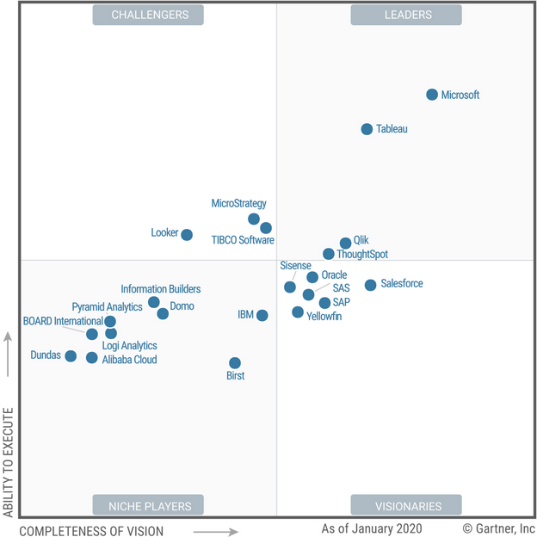

**Magic Quadrant for Data Science and Machine Learning Platforms**

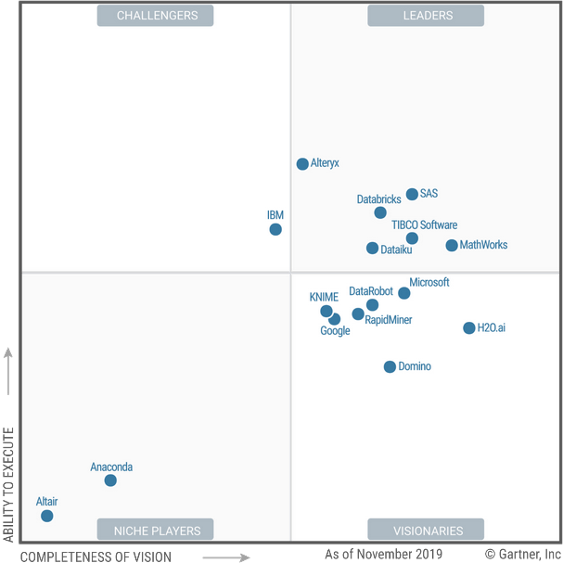

The 3 research subjects will be outlining a contrast and comparison of strengths and weaknesses of the following companies:

1. Microsoft
2. Sisense
3. ThoughtSpot

We will be comparing Microsoft as a leader and a visionary. ThoughtSpot as a leader, and Sisense as a visionary as per the Magic Quadrants above. I have selected to conclude a final recommendation based on only 2 of the following companies Microsoft and Sisense for the comparison of business intelligence analytics software platforms.

Below is the strength and weakness outline of the following companies as per the research from the Gartner Magic Quadrant report.

**Microsoft**

Microsoft is a Leader and a visionary in the Gartner Magic Quadrant. It has a comprehensive and visionary product roadmap and massive market reach through its Microsoft Office channel.

Microsoft offers data preparation, visual-based data discovery, interactive dashboards and augmented analytics in Power BI. It is available as a SaaS option running in the Azure cloud or as an on-premises option in Power BI Report Server. Power BI Desktop can be used as a stand-alone, free personal analysis tool. Installation of Power BI Desktop is required when power users are authoring complex data mashups involving on-premises data sources.

Microsoft releases a weekly update to its cloud service, which added hundreds of features in 2019. Recent additions include decomposition tree visuals, LinkedIn data connectivity, and geographic mapping enhancements.

Strengths

“Viral” spread: Although the price of Power BI Pro, at $10 per user per month, has helped the product’s market traction, this is secondary to its inclusion in Office 365 E5, which makes it “self-seeding” in many organizations. Prompts in other Microsoft Office products, like Excel, encouraging users to “visualize in Power BI” increase its exposure further — its reference customers claimed more deployments with more than 1,000 users than those of any other vendor in this Magic Quadrant. Power BI is now almost always mentioned by users of Gartner client inquiry service who ask about ABI platform selection.

Product capabilities: For years following its 2013 launch, Power BI was a “follower” product that had only to be “good enough,” given its price. That is no longer the case — and with the releases in 2019, the Power BI Pro cloud service overtook most of its competitors in terms of functionality. It outstripped many by including innovative capabilities for augmented analytics and automated ML. AI-powered services, such as text, sentiment and image analytics, are available within Power BI and draw on Azure capabilities. The vast majority of Microsoft’s surveyed reference customers would recommend Power BI without qualification.

The comprehensiveness of product vision: Microsoft continues to invest in a broad set of visionary capabilities and to integrate them with Power BI. This aligns well with the openness, consumerization and automation trends identified by Gartner as key market drivers.

Weaknesses

On-premises version: Compared with the Power BI Pro cloud service, Microsoft’s on-premises offering has significant functional gaps, including dashboards, streaming analytics, prebuilt content, natural language Q&A, augmentation (what Microsoft calls Quick Insights) and alerting. None of these functions are supported in the Power BI Report Server.

Azure-only: Microsoft does not give customers the flexibility to choose a cloud IaaS offering. Its offering runs only in Azure.

Connectivity: Power BI offers a very wide range of data connectors, but feedback from users of Gartner’s client inquiry service indicates that the query performance of on-premises data gateways is variable and requires effort to optimize. Connectivity to SAP BW and HANA direct queries is problematic — a known issue that Microsoft is working on. Customers generally choose to load data into Power BI instead, which is more performant.

**Sisense**

Sisense is a Visionary in the Gartner Magic Quadrant, one best known for its success with the embedded use case. Its new emphasis on serving the “builder” buyer persona represents a change in marketing focus and market segmentation as it seeks competitive advantage.

Sisense provides an ABI platform that supports complex data projects by offering data preparation, analytics, and visual exploration capabilities. Half of its ABI platform customers use the product in an OEM form.

Sisense 8.0.1 was released in September 2019 with new ML capabilities to uncover hidden insights and suggest new visualizations. In May 2019, Sisense acquired Periscope Data to reinforce its advanced analytics capabilities. The integration of the products has begun and will continue over the coming months.

Strengths

Native cloud BI: Sisense was early to re-architect its offering as a cloud-native analytics platform. It can run on modern scalable cloud applications such as Docker containers and Kubernetes orchestrations. The underlying components can be elastically scaled within Sisense’s managed cloud offering or the client’s deployment.

Support for complex data mashups: Sisense has continued to add augmented data preparation capabilities to Elasti-Cube, the vendor’s proprietary caching engine that uses both in-memory and in-chip processing for fast performance. By introducing augmented text deduplication, Sisense can automatically deduplicate incorrect or misaligned data and group similar strings.

Uses for enterprise standard: Sisense’s reference customers strongly consider it their sole enterprise ABI platform standard. An improved, open, single stack with an entirely browser-based interface helps customer penetration.

Weakness

Depth of use: Responses from Sisense reference customers indicated that a high proportion of customers manage complex data projects, but that a low proportion of Sisense users do moderately complex or highly complex ad hoc analysis and discovery, relative to the market norm.

Narrow marketing focus: Sisense’s acquisition of Periscope has sharpened its focus on power users and developers, whom it terms “builders,” and the integration of Periscope gives Sisense additional capabilities to enable data professionals to perform data science and analytics. But although this sharpened focus brings differentiation, it represents a somewhat narrower, less consumer-oriented vision than that of Sisense’s key competitors.

Deployment size: Although Sisense has continued to grow its strategic accounts and has some very large deployments with thousands of active users, deployment sizes (judged by the number of users) remain small, in comparison to other vendors. The percentage of reported deployments for over 500 people was low.

**ThoughtSpot**

ThoughtSpot is a Leader in the Gartner Magic Quadrant. Its innovative search-first approach remains attractive and continues to be emulated, but its differentiation is becoming slim.

ThoughtSpot differentiates itself with its search-based interface, which supports analytically complex questions with augmented analytics at scale.

In 2019, ThoughtSpot raised an additional $248 million in Series E funding, to bring its total venture capital investment to $554 million. During the year, it deepened its augmented analytics capabilities, introduced new AI-driven crowdsourced-driven recommendations, and added new autonomous monitoring of business metrics. Importantly, ThoughtSpot also added an in-database query option, initially for Snowflake and subsequently for Amazon Redshift, Google Big Query and Microsoft Azure Synapse.

Strengths

Specialism in search and AI at scale: Given ThoughtSpot’s search feature, and use of NLP as the primary interface for querying data, questions can be posed by typing or speaking. ThoughtSpot supports analytically complex questioning of large amounts of data, with more than one-third of its reference customers analyzing over 1 terabyte of data. SpotIQ, ThoughtSpot’s augmented analytics capability, discovers anomalies, correlations, and comparative analysis between data points without the need for coding.

Consumer-oriented and augmented product vision: ThoughtSpot is prioritizing the building of Facebook-like consumer experiences into its platform. Priorities include continuous feeds of related content (for example, to monitor individual headline metrics), automated anomaly detection and proactive alerting.

Market awareness: Despite ThoughtSpot's relatively small size, the market’s awareness of its search-based value proposition is high. This vendor is shortlisted by most of the customers who make use of Gartner’s client inquiry service when prioritizing NLP and augmented analytics features.

Cautions

Gaps in data preparation, visual exploration, and dashboards: ThoughtSpot’s software typically complements other products and does not cover the full spectrum of ABI requirements. Data must be prepared and cleaned using third-party tools to either load data into ThoughtSpot’s massively parallel processing engine or a high-performance database like Snowflake for in-database processing. The software does not allow users to readily manipulate data into groups or bins without using formulas, and dashboards are basic, lacking rich mapping features. Relatively few reference customers viewed ThoughtSpot as their only enterprise standard for ABI.

Limited global reach, ecosystem, and user community: Relative to the other Leaders in this Magic Quadrant, ThoughtSpot has a limited international presence, but one that is growing. Its partner ecosystem is a work in progress, with new investments having been made in 2019. However, the customer impact of these investments has yet to be seen. Gartner Peer Insights reviewers’ ratings of ThoughtSpot are lower than those for most other vendors in this Magic Quadrant for user community and availability of third-party resources.

The requirement for IT setup: Successful implementation of ThoughtSpot’s software requires data preparation and mapping of data in advance. This typically demands IT skills and effort. Moreover, ThoughtSpot’s product offers limited prebuilt content for specific vertical and functional domains. Customers must build their applications for particular functional areas.

**Comparison and contrast conclusion**

Based on the information from the following companies above. We can see that Microsoft offers an all-inclusive environment to handle new business intelligence applications. It is priced affordably and offers more integrated solutions really for companies who need to move from being non-data driven. While supporting the existing infrastructure within the needs of its platform through its azure cloud platform and Power BI ABI tools. Azure and Power BI are a very mature system that is always evolving.

Azure allows companies to easily integrate and set up resources for ETL, storage, API, and custom development in transferring past historical data and offers customizable BI tools such as Microsoft BI which seamlessly connect to Azure cloud platform resources to visualize data into sound decision-making information.

It facilitates scalability with integration to custom developments and many different programming environments utilizing many different programming languages or Frameworks. Microsoft offers all-in-one solutions that are versatile but may not have the flexibility when it comes to custom development and integration of tools and features it does not support.

Sisense is more of a marketing-focused platform that provides a business analytics platform. Complex data projects, Analytics, and visualization. Silence is a great platform that Native capabilities for custom mobile application development scalability does not offer the storage and transformation resources in such an elaborate fashion as Microsoft Azure offers. But it does offer more open-source capabilities and Integrations to be customized specifically 250 customers indicated analytic needs.

Sisense is a big data analytics solution that enables businesses to analyze and visualize large volumes of data with very complex data sets. Whereas Microsoft power BI is used primarily for decentralized analytics and centralized business intelligence provision by power users and its Developers.

The Azure platform does, however, facilitate the resources to handle big data analytics and large volumes of data. Depending on how in-depth a new or established company wants to develop its Solutions or how much flexibility they need to scale would vary on these points.

I would highly recommend using the Azure platform for companies just seeing into utilizing their data to make business sessions on this level. From setting up transforms getting the results needed to facilitate the bottom-line decisions for a quicker solution. Whereas Sisense would be a point of interest after XYZ company has established becoming data-driven and a need for native features. To have a more centric platform that can handle complex transformation through the machine and deep learning on a more customizable and programmatic level.

**References:**

Gartner( 11 February 2020) Magic Quadrant for Data Science and Machine Learning Platforms.<https://www.gartner.com/doc/reprints?id=1-1YDUKTC6&ct=200217&st=sb>

Gartner( 11 February 2020). Magic Quadrant for Analytics and Business Intelligence Platforms.<https://www.gartner.com/doc/reprints?id=1-1Y7VEZB3&ct=200128&st=sb>